**41. helm lint**

--- the Helm Lint Command, the Helm Lint Command will scan through all the template files and the values.yaml files for our chart and it checks if there are any issues, weather there is Syntactical issues are indentation issues in the yaml files to use it,

**# Check for the syntax issues in our chart**

--- helm lint firstchart

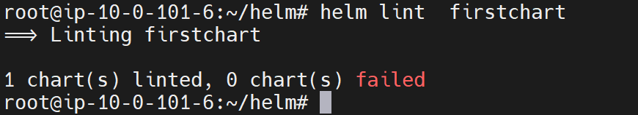

--- note – it will also check for syntax in zip file as well.